Competency-Based Curriculum

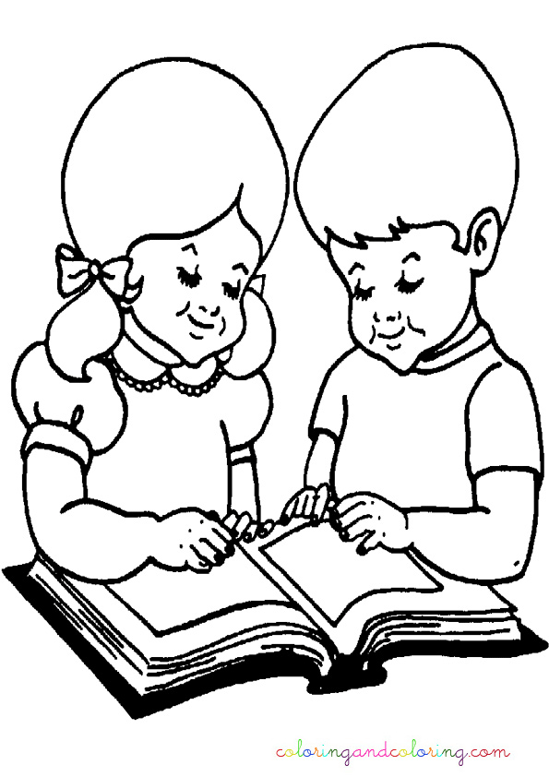

Study Pack

Grade 1

Volume 1

Train a child than repair a man